

**Farm2GO**

**Submitted by:**

GABUAN, SHANNAIAH LOVE

MARIANO, DEO JOHN STEVEN

MONTE DE RAMOS, MARIEL

Eustaquio, Adriell Jaldy

ADDUN, BERNARD

**Submitted to:**  
Anjelica Castillo

**System Architecture Diagram**

*(Please upload your Diagram in PNG format you may use* [*https://draw.io/*](https://draw.io/) *as your tool to create it.)*

Description

**User Interface**

*(Attach the screenshot of your UI each project specification indicating the description of it. You may add according to your list of specification)*

**User Interface 1**

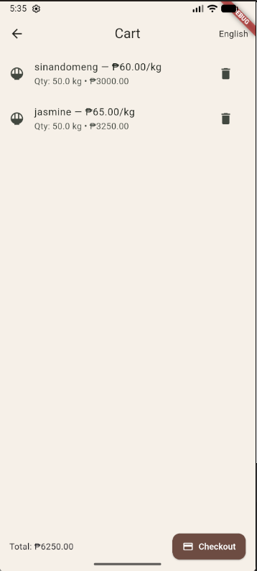

**Description:**

This interface is displayed when a user taps a product card on the Marketplace screen. It provides in-depth information about the product.To help buyers make informed purchasing decisions before checkout.The **Cart Interface** displays all products that a buyer has added before checkout.To manage and summarize the buyer’s intended purchases before confirming the order.The **Checkout Interface** finalizes the order transaction, confirming delivery details and payment.To ensure smooth, error-free finalization of a buyer’s order.

**User Interface 2**

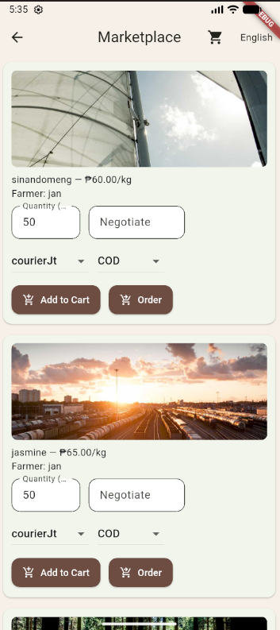

The **Marketplace Interface** serves as the home screen for buyers. It displays a list of available agricultural products such as *Sinandomeng*, *Jasmine*, and *Dinorado* rice, along with their images, prices, and sellers.To provide a user-friendly way for buyers to browse, compare, and select products available from local farmers.

**User Interface 3**

**Description:**

A management panel for farmers to upload and manage their products.To give farmers full control of their digital store presence in Barangay Palayan.

**User Interface 4**

**Description:**

This is the unified sign-in page for all user types.To ensure secure and role-based access across all user categories.

**Code Snippet**

*(Attach the screenshot of your sample Flutter user interface code snippet.* ***NOTE:*** *Just the Model itself.)*

**Code Snippet 1**

**Code Snippet 2**

**Code Snippet 3**

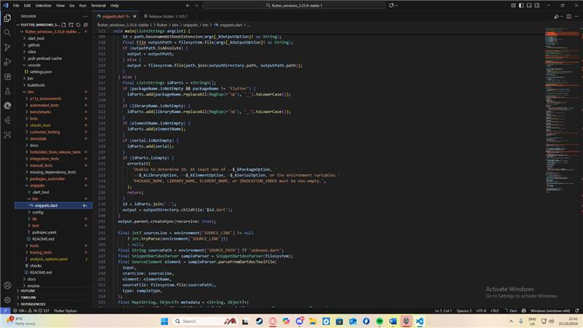

**Code Snippet 4**

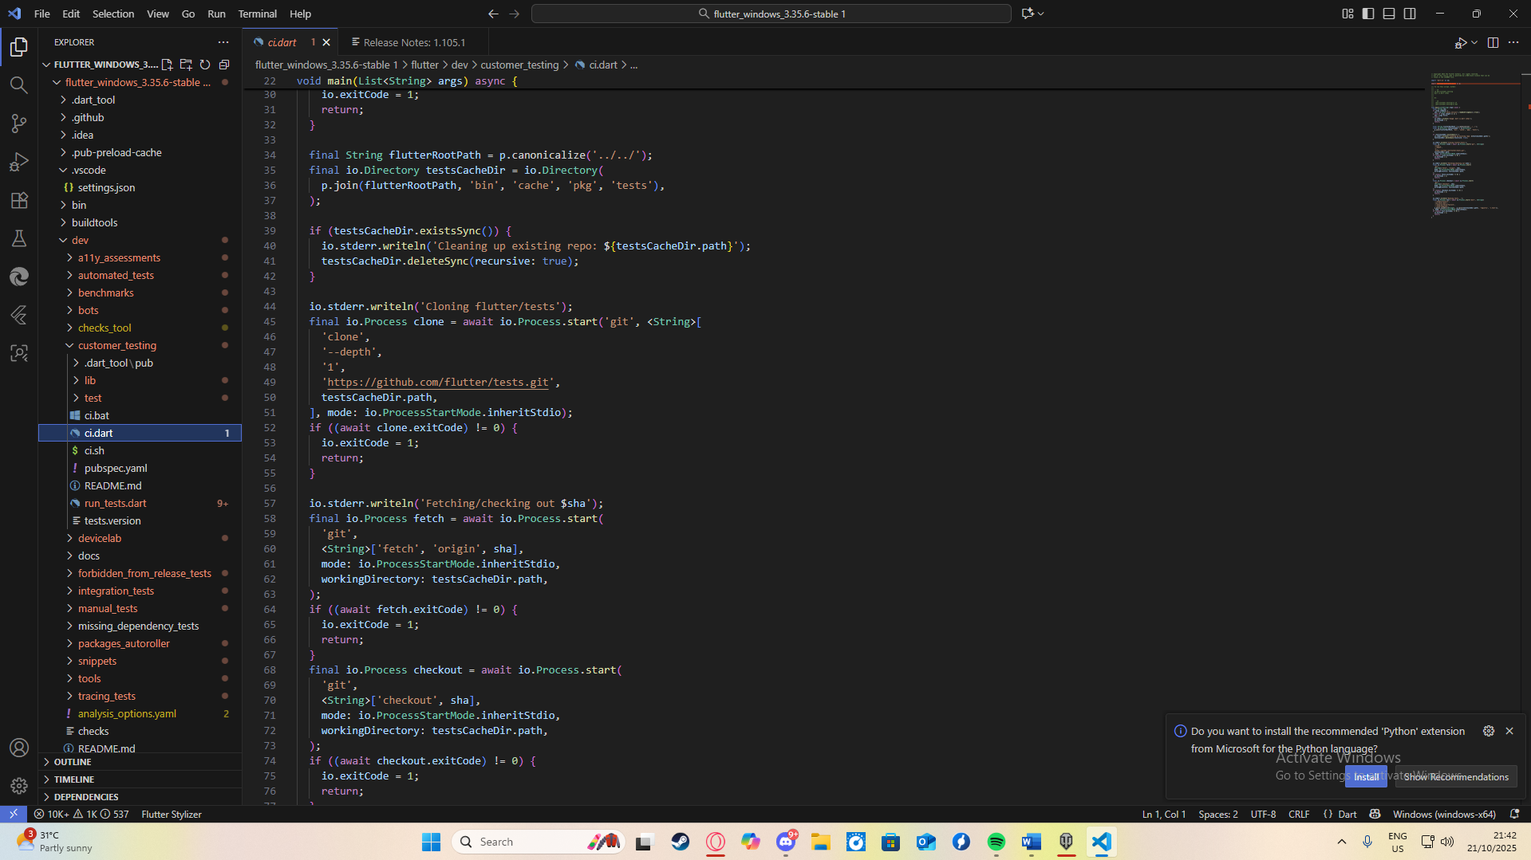

**Code Snippet 5**

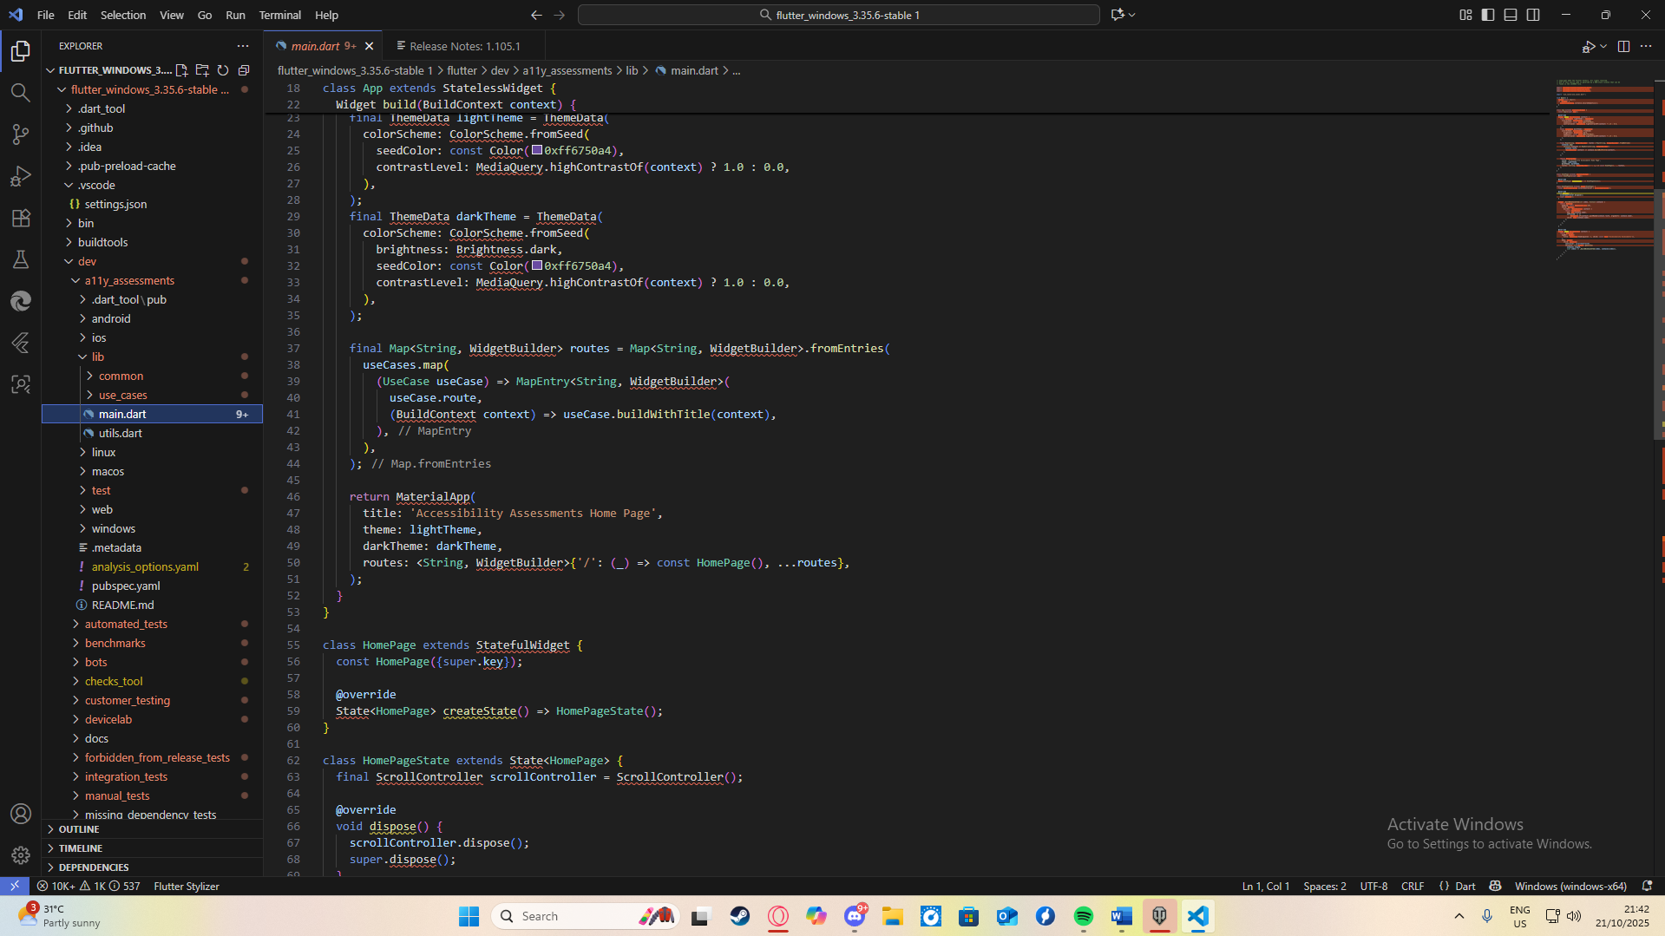**Project Rubric**

|  |  |  |  |  |
| --- | --- | --- | --- | --- |
| **Course Code** | CWBCOML | **Course/Subject** | Web Commercialization and eCommerce | |
| **Term/Academic Year** | TERM 1 / 2025-2026 | | | |
| **Group Name** | TORO FAMILY | | | |
| **Members** | **Surname, First Name MI. (Alphabetical)** | | | **Signature** |
| Gabuan, Shanniah Love | | |  |
| Monte de Ramos, Mariel | | |  |
| Addun, Bernard | | |  |
| Mariano, Deo John Steven | | |  |
| Eustaquio, Adriell Jaldy | | |  |

|  |  |  |  |  |  |  |  |  |  |  |
| --- | --- | --- | --- | --- | --- | --- | --- | --- | --- | --- |
| **Project Component** | **SO** | | **Unsatisfactory**  **(0)** | | | **Needs Improvement**  **(1)** | **Satisfactory**  **(2)** | **Proficient**  **(3)** | **Exceptional**  **(4)** | **PTS** |
| **User Interface, Design & Navigation** | **SO6** | | Unattractive, outdated design; inconsistent layout; non-responsive; confusing navigation. | | | Basic design with minor inconsistencies; limited responsiveness; partially intuitive navigation. | Visually acceptable, consistent layout; responsive on most devices; easy navigation. | Attractive, modern design; fully consistent across all pages; highly responsive; intuitive navigation. | Professional, modern UI with excellent visual appeal, seamless responsiveness, and flawless navigation experience. |  |
| **Functionality & Core Features** | Major features missing or non-functional (e.g., browsing, search, cart, checkout). | | | Some core features functional but with major bugs or incomplete implementation. | All core features functional (browsing, search, cart, checkout) with minor issues. | Fully functional features with smooth interactions and proper error handling. | Exceptional functionality with additional enhancements beyond requirements; flawless performance. |  |
| **Security & Data Management** | No HTTPS; weak or no authentication; poor data protection; vulnerable to attacks. | | | Basic security measures implemented but with noticeable vulnerabilities. | Secure authentication, basic encryption, and partial protection against attacks. | Strong security with HTTPS, encryption, and defenses against common attacks; efficient database handling. | Advanced security, full compliance with best practices, optimized database queries, high data integrity, and large dataset handling. |  |
| **Product & Order Management** | Admin cannot manage products/orders; product details incomplete; poor categorization. | | | Basic product/order management with limited functionality. | Functional product and order management with correct details and category organization. | Efficient product and order management with smooth updates and well-organized categories. | Advanced product and order management with bulk operations, automation, and optimal category/tagging. |  |
| **Documentation, Code Quality & Presentation** | **SO3** | | No or poor documentation; messy, unreadable code; unclear presentation. | | | Basic documentation; code readable but lacks structure; weak presentation skills. | Adequate documentation; code mostly organized; clear presentation with minor gaps. | Good documentation; clean, well-structured code; confident and clear presentation. | Comprehensive technical/user documentation; excellent code quality; engaging and professional presentation with confident Q&A. |  |
| **Total Score and Feedback** | | | | | | | | |  |  |
| Exceptional | | 20 | | Outstanding performance in all project components with minimal to no issues | | | | | **Total Points Earned** |  |
| Proficient | | 16-19 | | Good performance in most project components with minor issues. | | | | |
| Satisfactory | | 12-15 | | Acceptable performance in basic aspects with several issues. | | | | |
| Needs Improvement | | 8-11 | | Below-average performance with many issues. | | | | |
| Unsatisfactory | | 0-7 | | Poor performance with critical issues in most project components. | | | | |
| Evaluated by:  _______________________  Name of Course Instructor/Date | | | | | **Remarks/Comments** | | | | | |

**Individual and Self Evaluation Rubric**

|  |  |  |  |
| --- | --- | --- | --- |
| **Course Code** | Click or tap here to enter text. | **Course/Subject** | Click or tap here to enter text. |
| **Term/Academic Year** | Click or tap here to enter text. | | |
| **Group Name** | Click or tap here to enter text. | | |

|  |  |  |  |  |  |  |
| --- | --- | --- | --- | --- | --- | --- |
| **Student Name(s)**  ***All members including the evaluator.*** | **Contribution to Team Effort** | **Communication Skills** | **Meeting Deadlines and Reliability** | **Quality of Work** | **Collaboration and Teamwork** | **PTS** |
| Contributes meaningfully to group discussions. | Demonstrate excellence in written and verbal communication skills | Completes group assigned task(s) on time. | Prepares work in a quality manner | Demonstrate a cooperative and supportive attitude. |
| Using scale 0-4 (0=Unsatisfactory; 1=Needs Improvement; 2=Satisfactory; 3=Proficient; 4=Exceptional) | | | | |
| **SO5** | | | | |
| Click or tap here to enter text. |  |  |  |  |  |  |
| Click or tap here to enter text. |  |  |  |  |  |  |
| Click or tap here to enter text. |  |  |  |  |  |  |
| Click or tap here to enter text. |  |  |  |  |  |  |
| **Peer Evaluation Interpretation** | | | | | | |
| Exceptional | 20 | Outstanding performance across all indicators. | | | | |
| Proficient | 16-19 | Strong performance with minor areas for improvement. | | | | |
| Satisfactory | 12-15 | Adequate performance with several areas for improvement. | | | | |
| Needs Improvement | 8-11 | Below-average performance with significant areas for improvement. | | | | |
| Unsatisfactory | 0-7 | Poor performance across most or all indicators. | | | | |
| **Remarks/ Comments** | | | | | | |

**Evaluated By:**

**_________________________**

**Signature over Student Name**